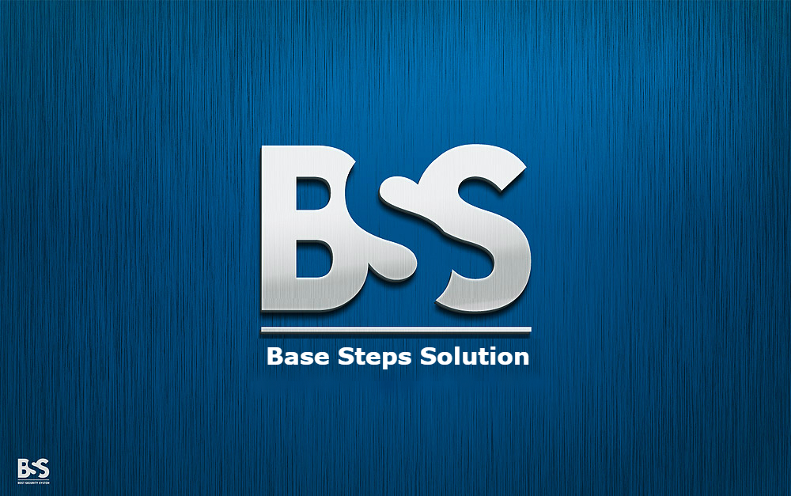

Communication Managemet Plan

Văn Lang Admissions

# Revision Table

|  |  |  |  |
| --- | --- | --- | --- |
| Author | Date | Reason for changes | Version |
| Hien Nguyen | 01/11/2016 | Initial the document | 1.0 |
|  |  |  |  |

Table of Contents

Revision Table 1

1. INTRODUCTION 3

1.1. Purpose 3

1.2. Definitions, acronyms and abbreviations 3

1.3. Intended Audience 4

1.4. Intended Audience 4

2. Stakeholder indentification & analysis 4

3. Communication plan 5

# INTRODUCTION

## Purpose

This document will help all stakeholder know how to communicate with each other. It will serve as a guide for communications throughout the life of the project and will be updated as communication needs change. This plan identifies and defines the roles of persons involved in this project.

## Definitions, acronyms and abbreviations

This following table describes key terms and important acronyms in this project:

|  |  |  |
| --- | --- | --- |
| No. | Term | Definition |
| 1 | N/A | Not Assigned |
|  |  |  |

## Intended Audience

|  |  |
| --- | --- |
| Intended Audience | Name |
| Customers | Nguyễn Thế Quang |
| Mentor | Lê Sĩ Phú |
| Project team | Base Steps Solution |

## Intended Audience

* Team rules document
* Configuration document
* Team effort log

# Stakeholder indentification & analysis

|  |  |  |  |
| --- | --- | --- | --- |
| No | Name | Role | Responsibility |
| 1 | Nguyễn Thế Quang | Customer | - Accept the final deliverable of this project  - Be informed of the project status including potential impacts to the schedule of project. |
| 2 | Lê Sĩ Phú | Mentor | - Meeting with student teams once a week for status meeting  - Review and conduct weekly evaluation to student team(s) and each team member  - Publish the result of weekly evaluation to other mentors and students that he/she is mentoring.  - Provide metrics and reflection at the end of each milestone. |
| 3 | Nguyễn Thái Hiền | Leader | - Establish schedule for team.  - Manage plans.  - Evaluate team members.  - Synthesis document.  - Communication with team members. |
| 4 | Trần Xuân Hải | Sub-leader | - Contact with customers.  - Support leader. |
| 5 | Nguyễn Hoàng Anh Tài | Member | - Perform tasks that have been assigned. |
| 6 | Nguyễn Anh Khởi |
| 7 | Đoàn Anh Minh |
| 8 | Nguyễn Xuân Thái Hiền |

# Communication plan

|  |  |  |  |  |  |
| --- | --- | --- | --- | --- | --- |
| From | To | What are Communicated | What are gained | Method | Frequency |
| All members | Project Manager | - Time log  - Individual task completed | - What are done and not done | Github | Everyday |
| Project Manager | All Members | - Assign task  - Time log | - What are task will do  - Time to finish task | Github  Skype  Face to Face | Every Monday |
| Project Manager and all member | Mentor | - Weekly Report  - Review Document | - Know project progress  - Status of members. | Face to face  Email | Every Monday |
| Mentor | Project Manager and all member | - Feedback  - Give opinion for project. | - Solution for project.  - Fix document | Face to face  Email | every Monday |
| Customer | Project manager and Team member | - Requirement  - Feedback about product. | -Requirement document  - Reviewed Product | Face to face  Email | N/A |
| Project Manager and Team member | Customer | * Project progress   - Document | * Know project progress * User document. | Face to face  Email | N/A |